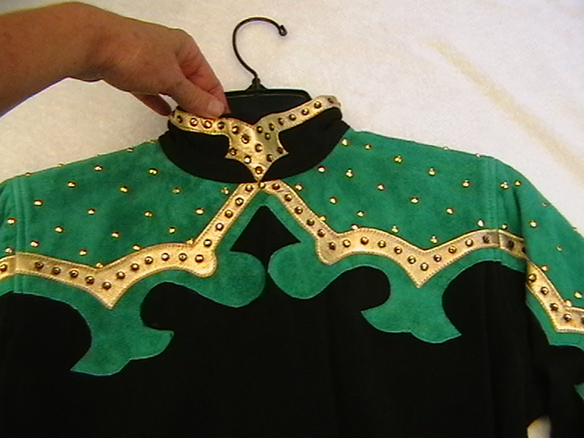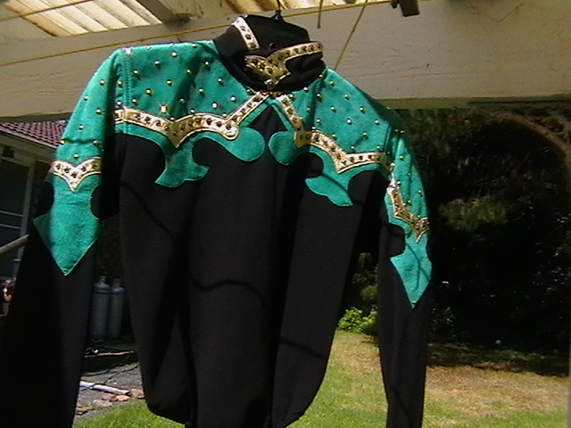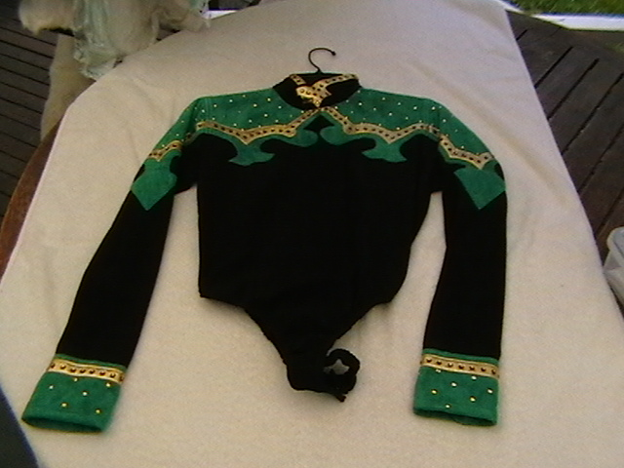
US Custom made Jade suede body suit, with black medium weight base with snap crotch, very slimming and just love that colour!. - loads of gold leather with all rimset crystals, zips up back - Stunning!. – size 8-10 $160.

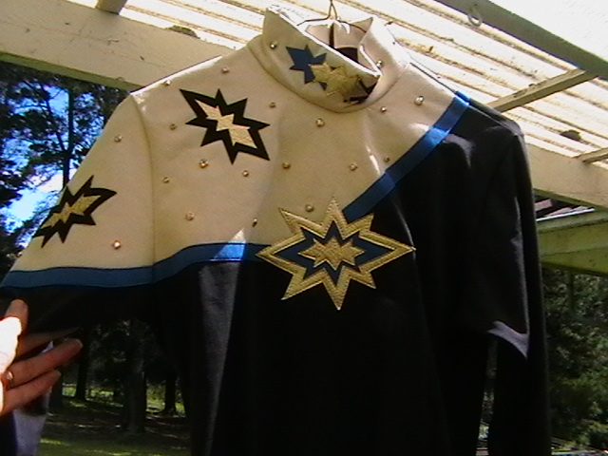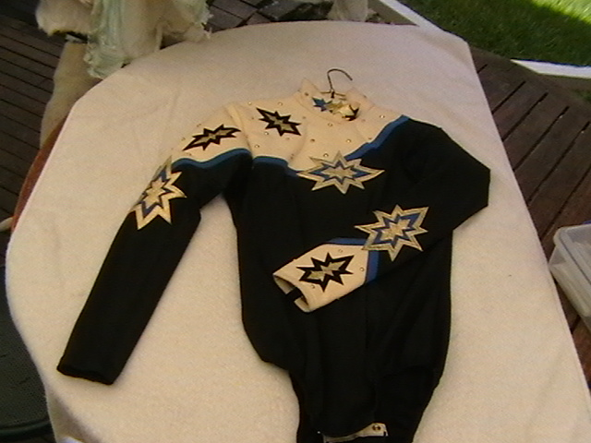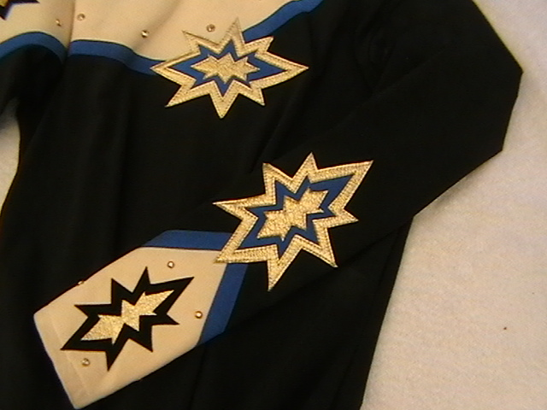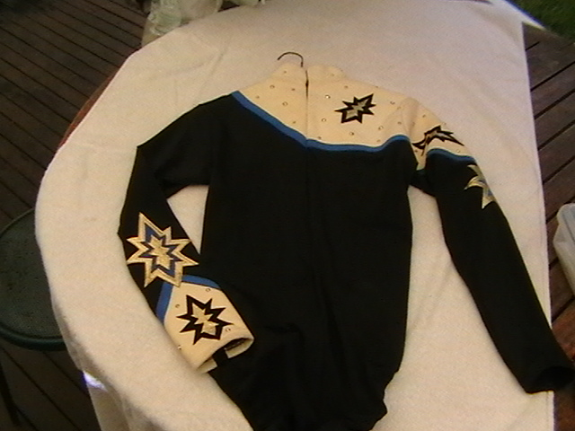
US Custom Made -Stunning cream gold and blue star top with very dark navy base, , suede feel cream material with all rimset stones and gold leather trim with blue ultrasuede trim…as new fits ladies 10-14 – very stretchy – will suit cream blue or black chaps – very versatile high class show top in excellent condition $160
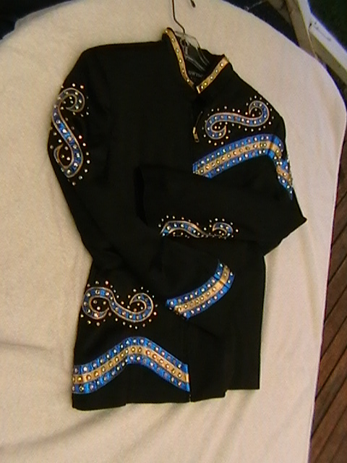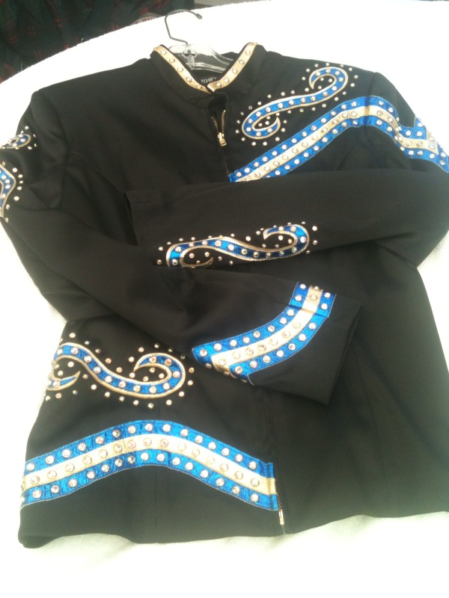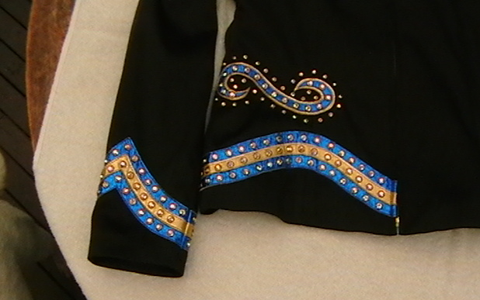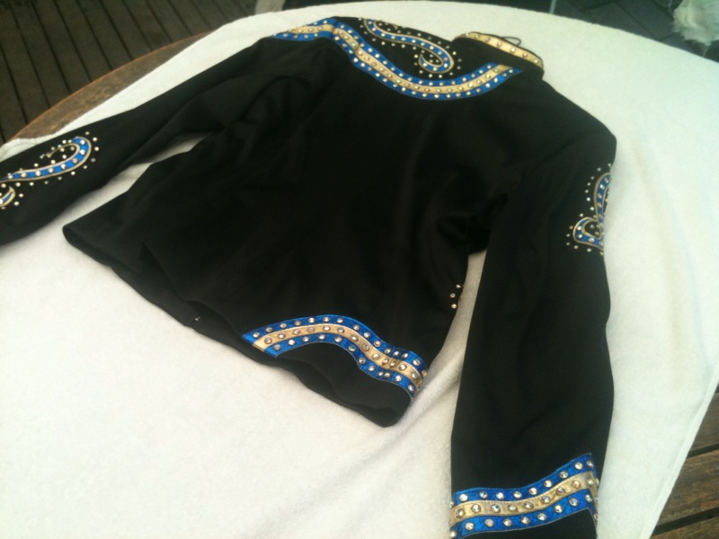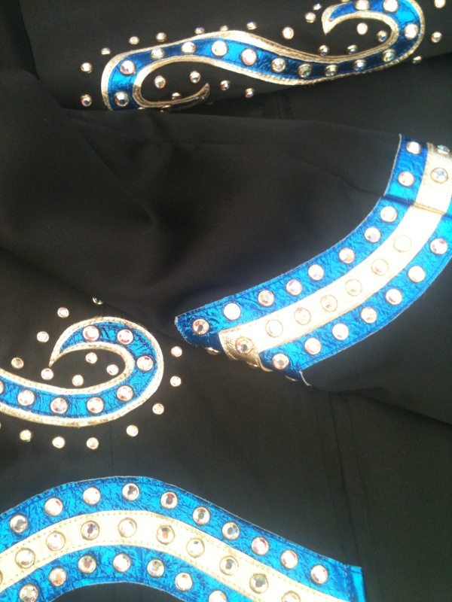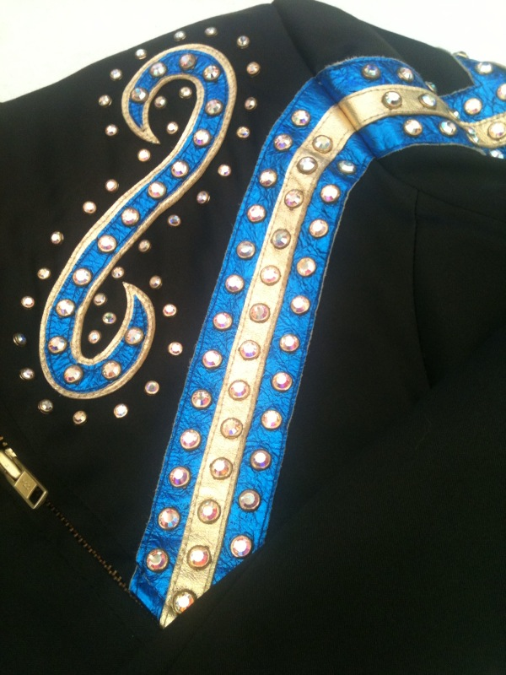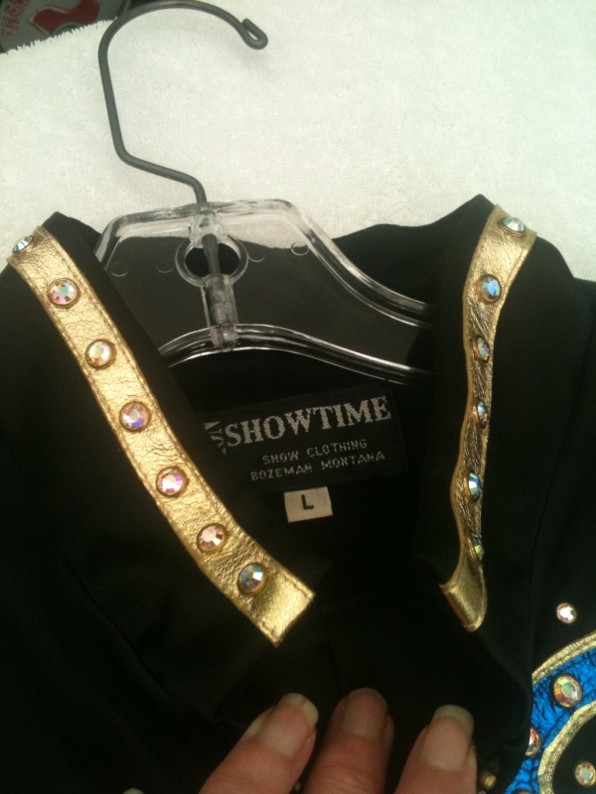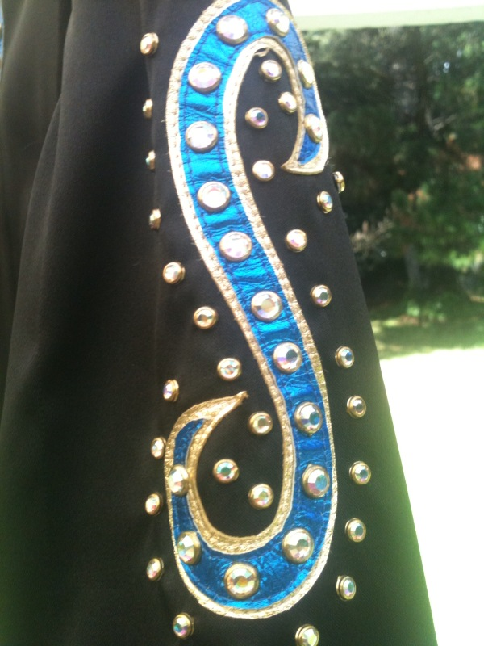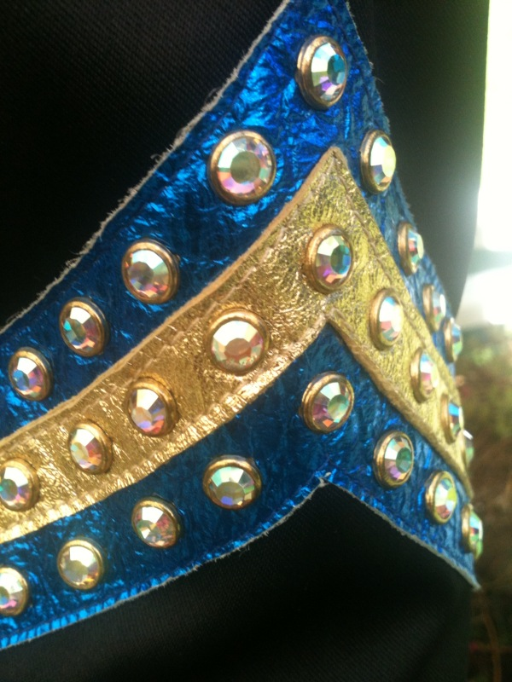

Showtime USA Jacket. Ladies Large – fits 12 perfect but could go 10 – 14 – this is very high quality as with all Showtime jackets, - it feels absolutely beautiful - slightly satiny fully lined and tailored fit - Electric blue and Gold leather design with masses of Aurora rimset stones – this cost a bomb new and has never been worn grab yourself a bargain – you don’t see this make or quality for that price!. Versatile On the Rail jacket or for showmanship! ne I can truly say the photos don’t do it justice $450

