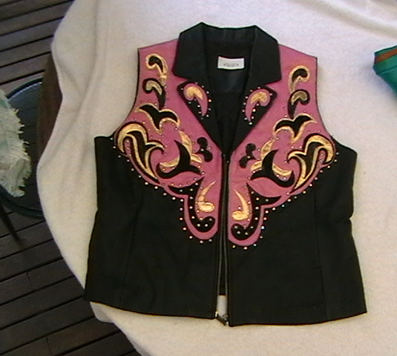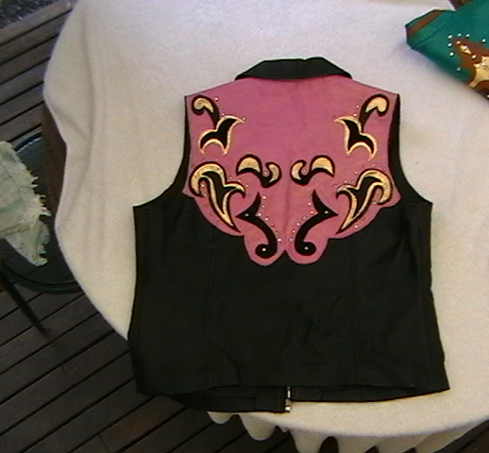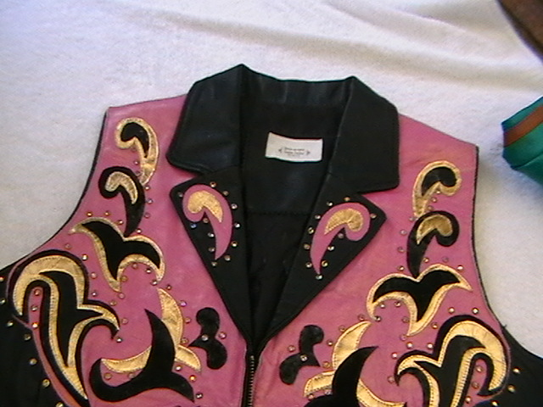
Show N Off Custom creation by Karma USA – Super nice all leather MuskPink Gold leather , with black and gold leather trim and rim set crystals - buttery soft leather with modern collar, Has been worn but in excellent condition – fits Ladies 12-14 Team it with a black crystal slinky $100
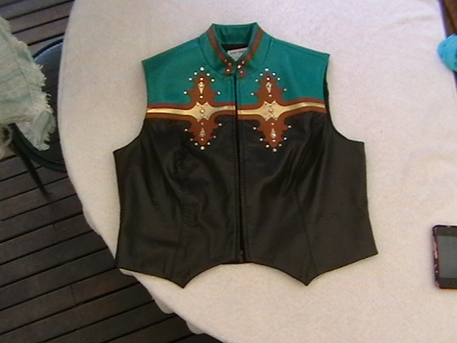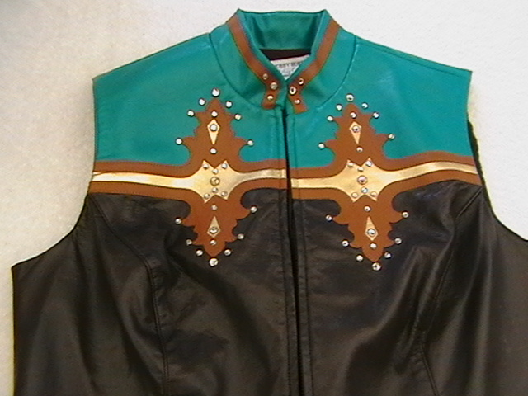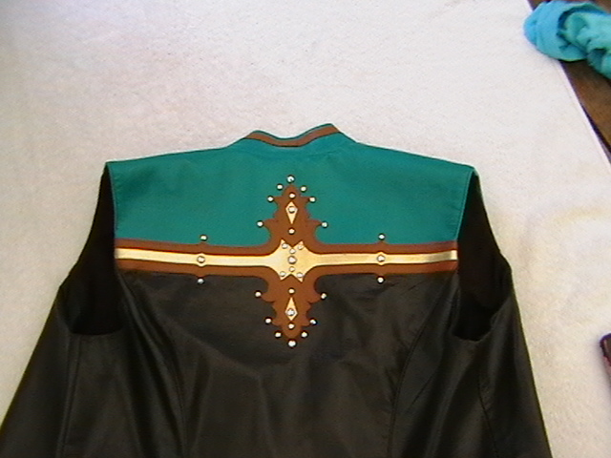

Hobby Horse XL/Ladies jade green, Tan, gold and dark chocolate leather like vest. With rimset crystals – New – fits size 10-12 – perfect match for the tan chaps too! $60.

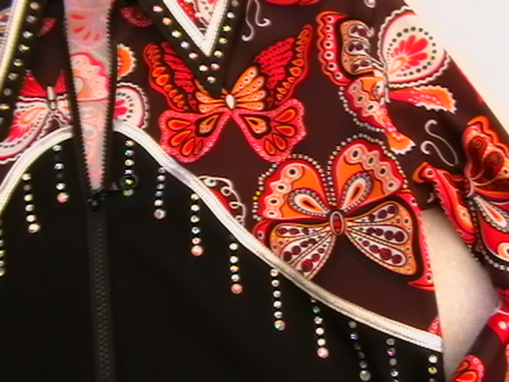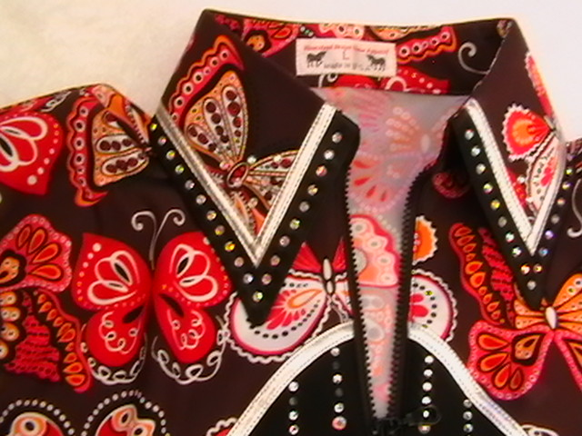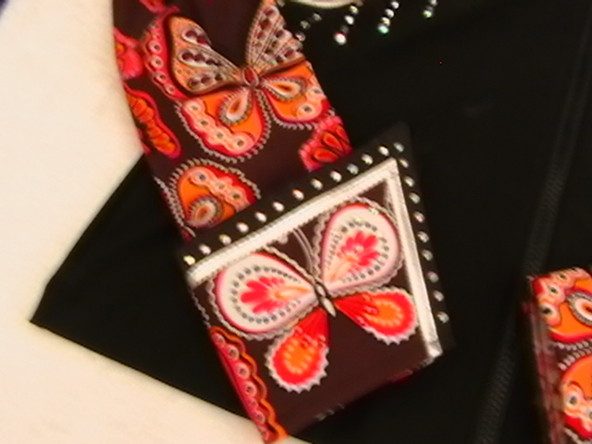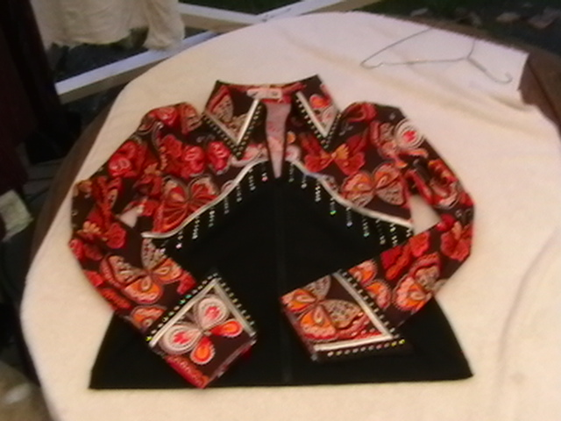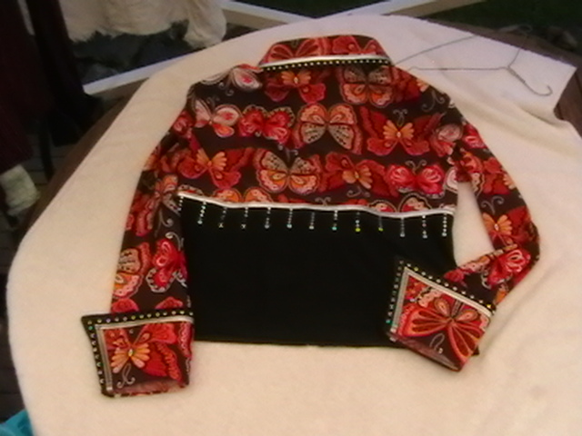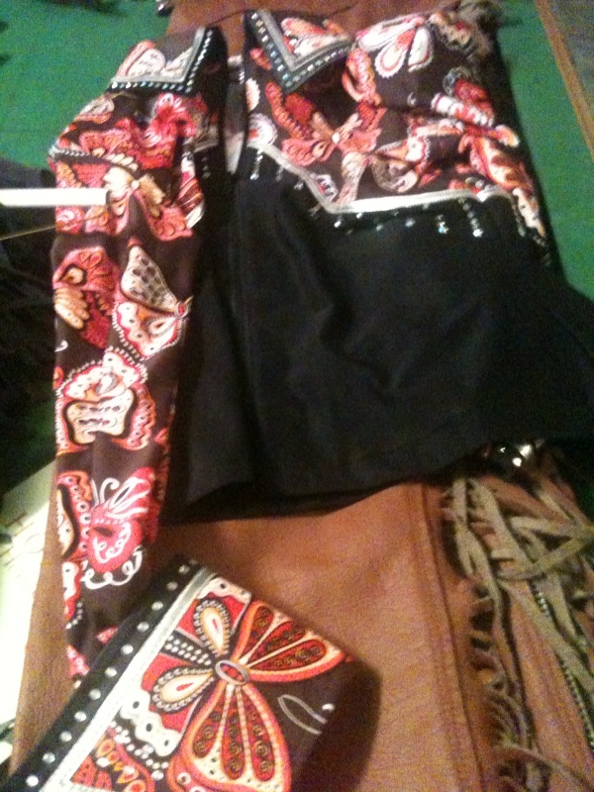
Heartland Designs USA, stand up collar, butterfly crystal top with earthy, red, pinks, orange butterflies on chocolate base with black bottom. Loads of iron on crystal drops and collar and cuff covered in larger iron on crystals. Some iron on crystals (not many) missing from bust line drops – cannot notice (in fact I only noticed today when photographing). – easily fixed with a packet of irons ons from Spotlight !. Brand new never worn. Light weight beautiful feel. Very slimming style Ladies Large – fits 12-14…$120 (goes with tan, cream or black chaps!!)

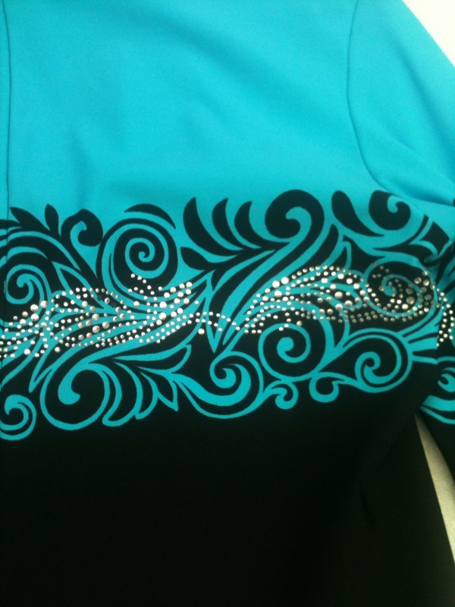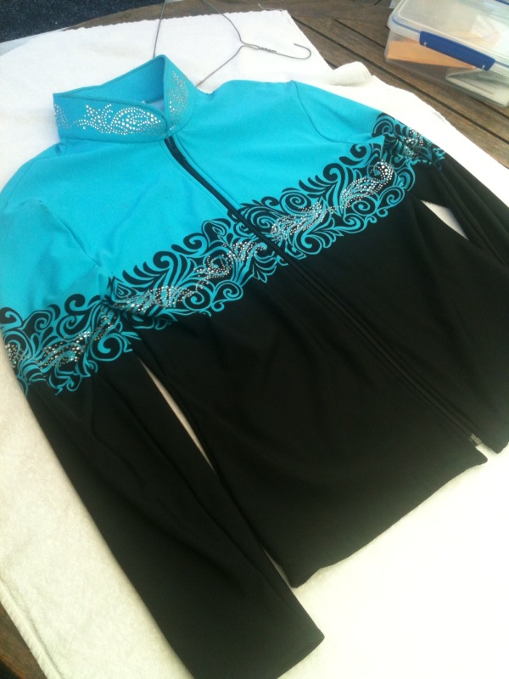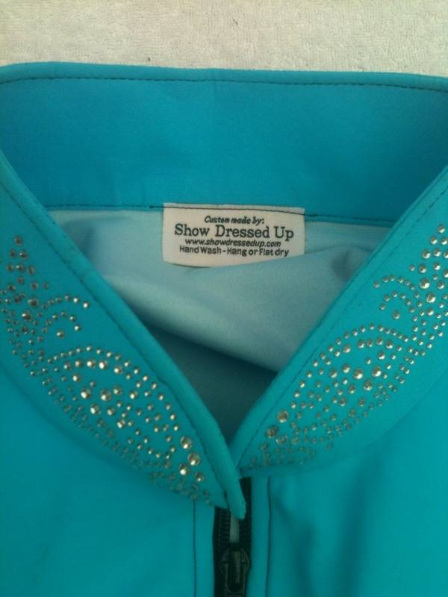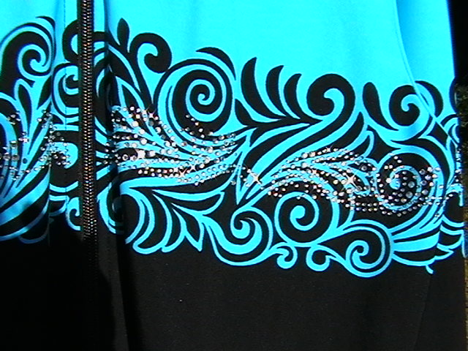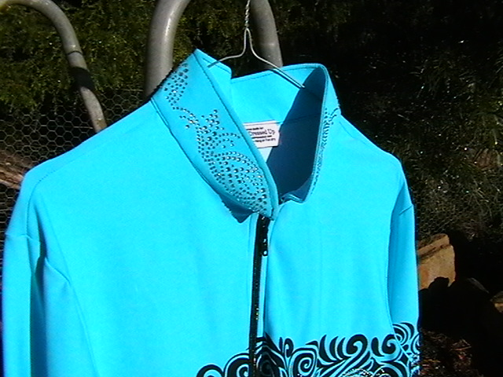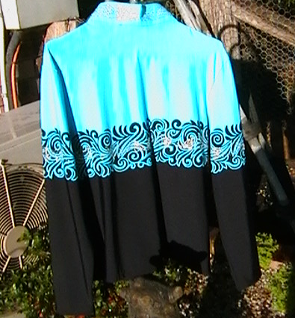 Show Dressed Up USA Turquoise tribal crystal shirt –very light weight – great for summer - Ladies 12-14 New never worn. Has a couple sewing stitches on collar that are skewed but you cannot notice – just saying!. – won’t affect its wearability. Beautiful with black chaps – loads of crystals. Has matching detachable black and crystal cuffs. $100.00

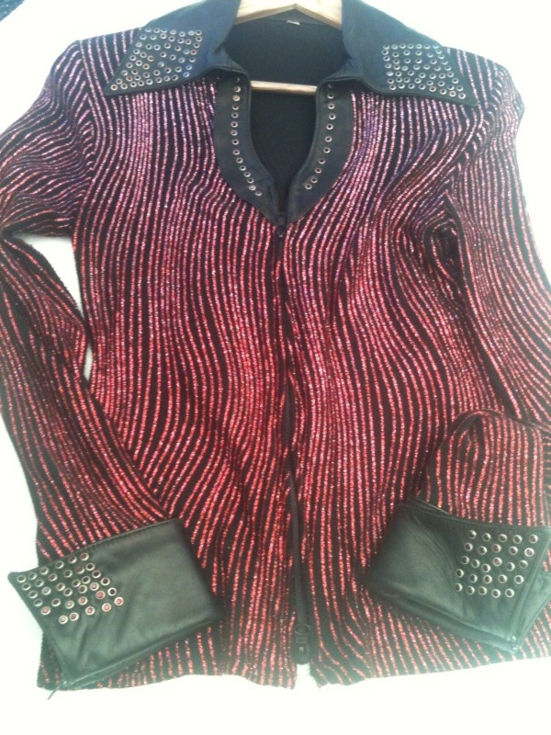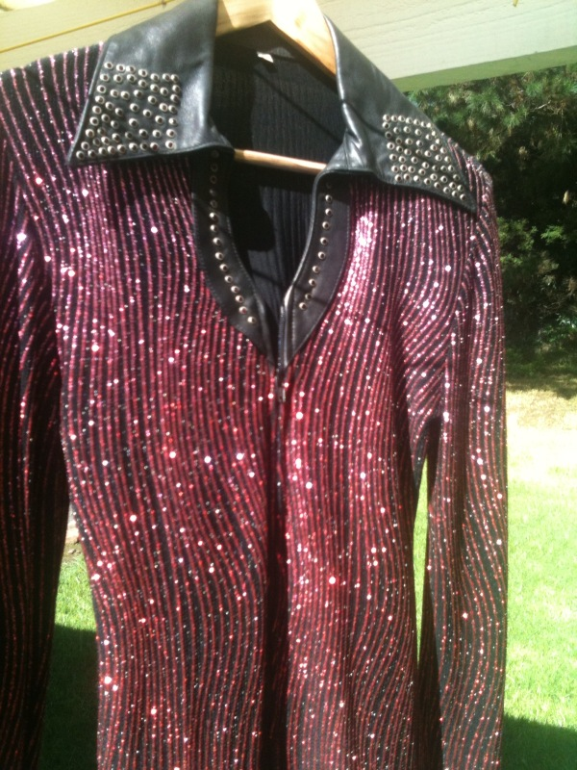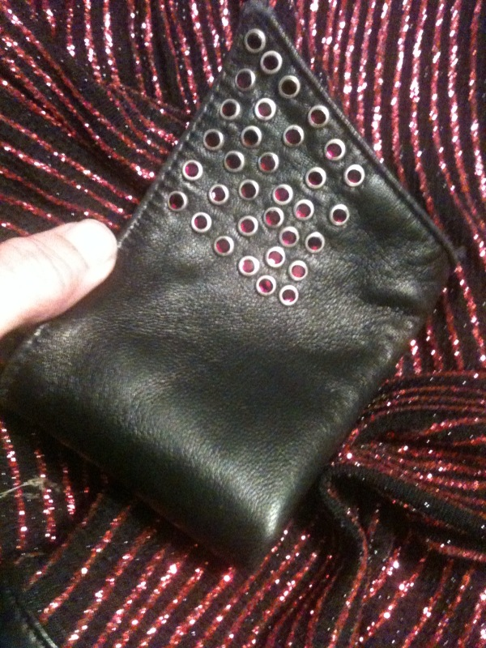
Unusual Raspberry glitter and buttery soft black leather show shirt - rimset red crystals all over collar and zipped leather cuffs, this is a great shirt and will definitely draw the judges attention - looks stunning at night and day !. And wow during the day. Great current styling collar and open neck, as new – Size 12-14 ladies – lots of stretch. $100

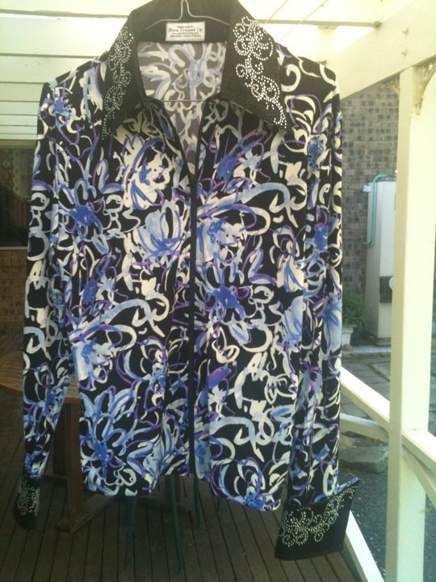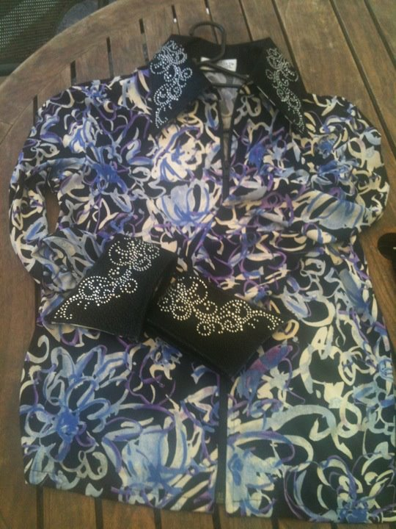

US Tobys Show Shirt – New – has loads of iron on crystals on collar and cuffs. Ladies 12/14 - really stands out in the ring – great match for the purple chaps I have for sale $80. (Never worn)

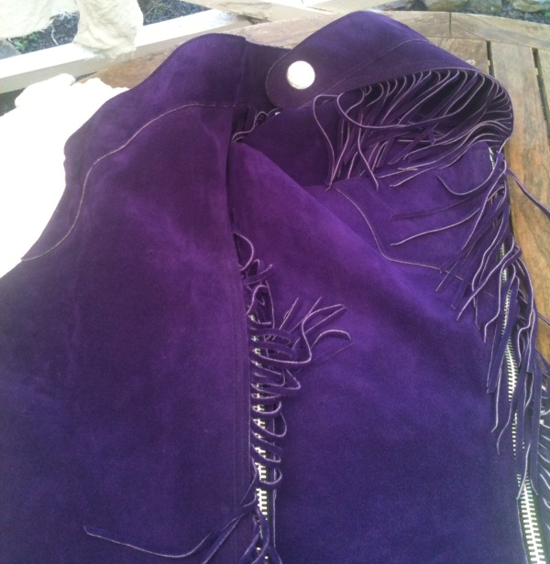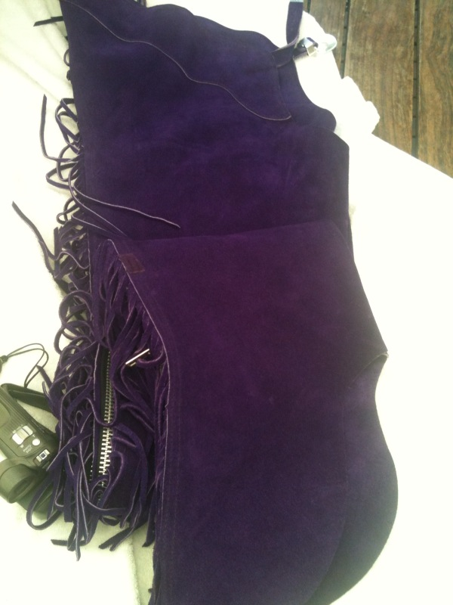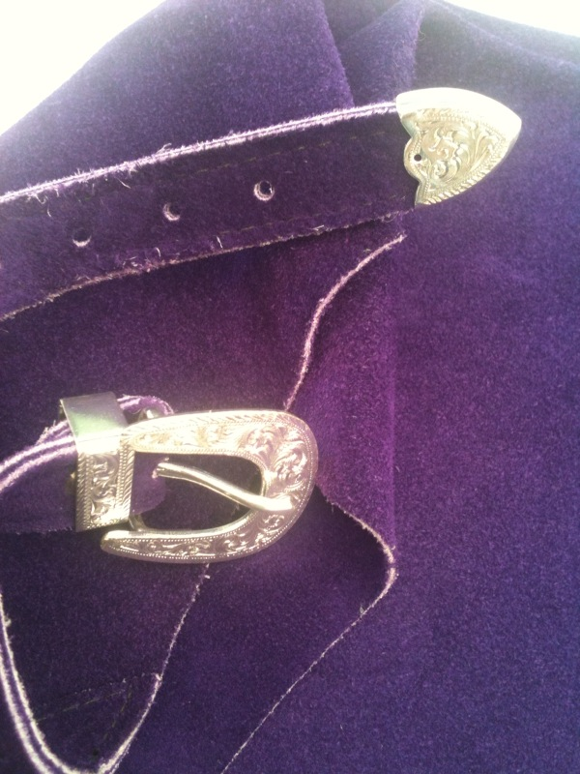
Whitman rich grape/purple suede Ladies Large equitation show chaps , drop heel, fringed, with concho back with fancy silver buckle set in front – Velcro at bottom to hold up heel when not on horse - new never worn – size 12/14 inseam 34 message me for exact measurements. (perfect with the purple squiggle top for sale) $200.00

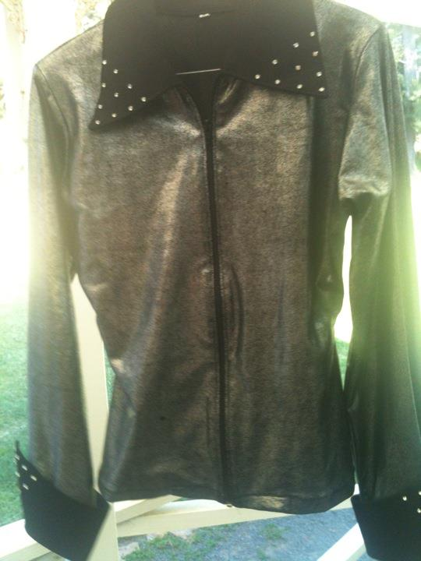

Silver/Platinum Show Shirt – NEW – Toby’s USA - $60 suit purple chaps or black chaps – great on a dark horse!. Lots of shimmer Ladies 12/14

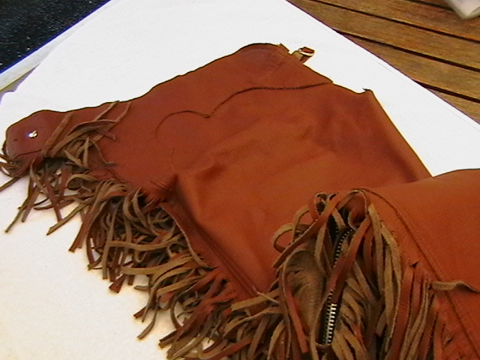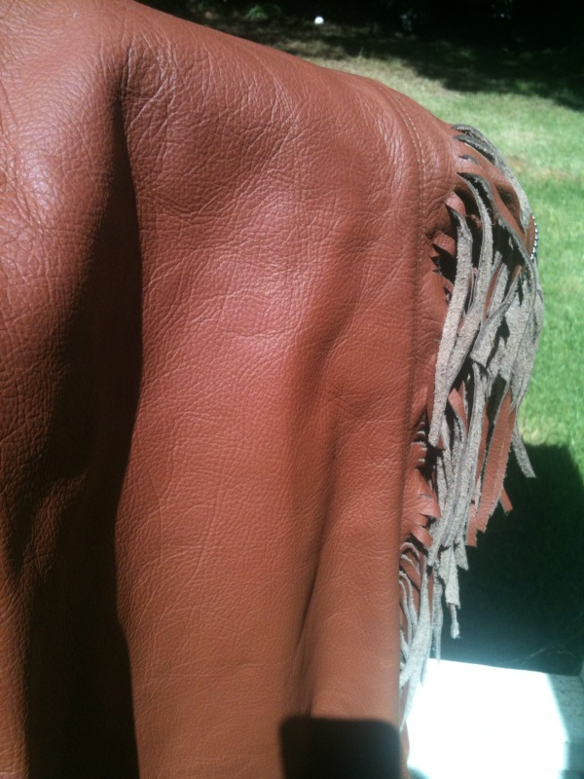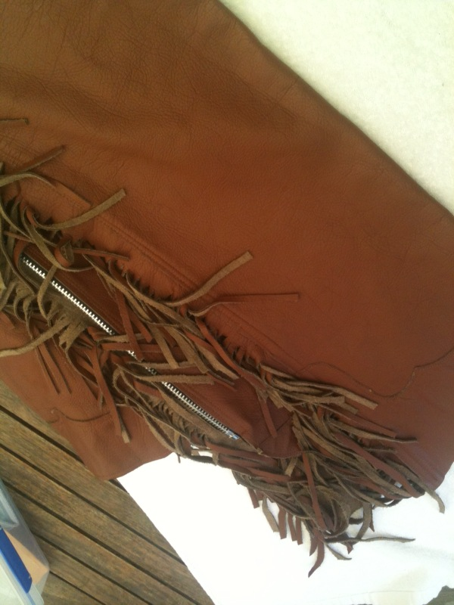
Tan ochre coloured smoothie leather equitation chaps – medium weight leather very soft and drapey – fanny fringe – needs concho at back and doesn’t have fancy buckle set , does up with leather strap that closes with Velcro but you could easily adapt that by adding a fancy buckle. Higher on hips sit just under belt - As new - picture in sun is closest to real colour . Ladies size 12/14 Not as high quality as say Hobby Horse but good to go show $100 (cheap!)

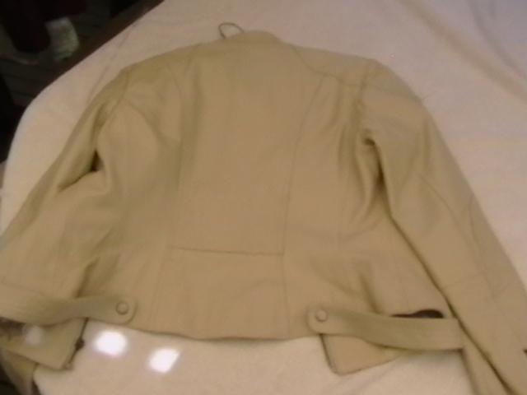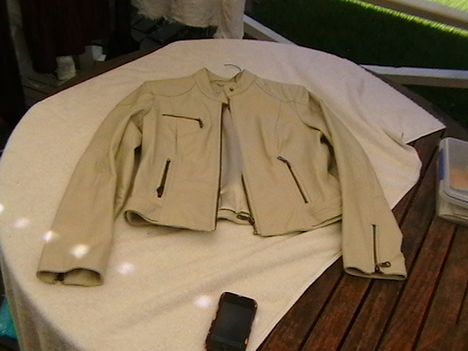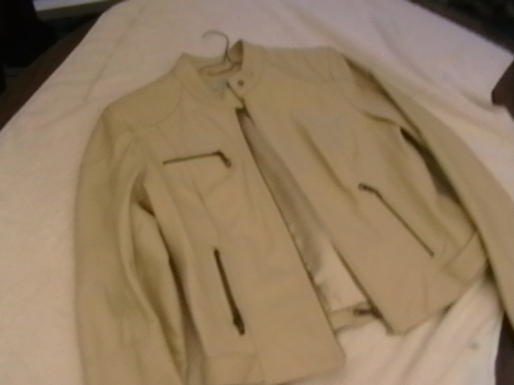
Next UK brand Leather Jacket - butter soft cream leather jacket as new worn once – fully satin lined – beautiful detail on back and sleeves - size 10-12/14 (marked 14 but smaller than normal 14) $100.

